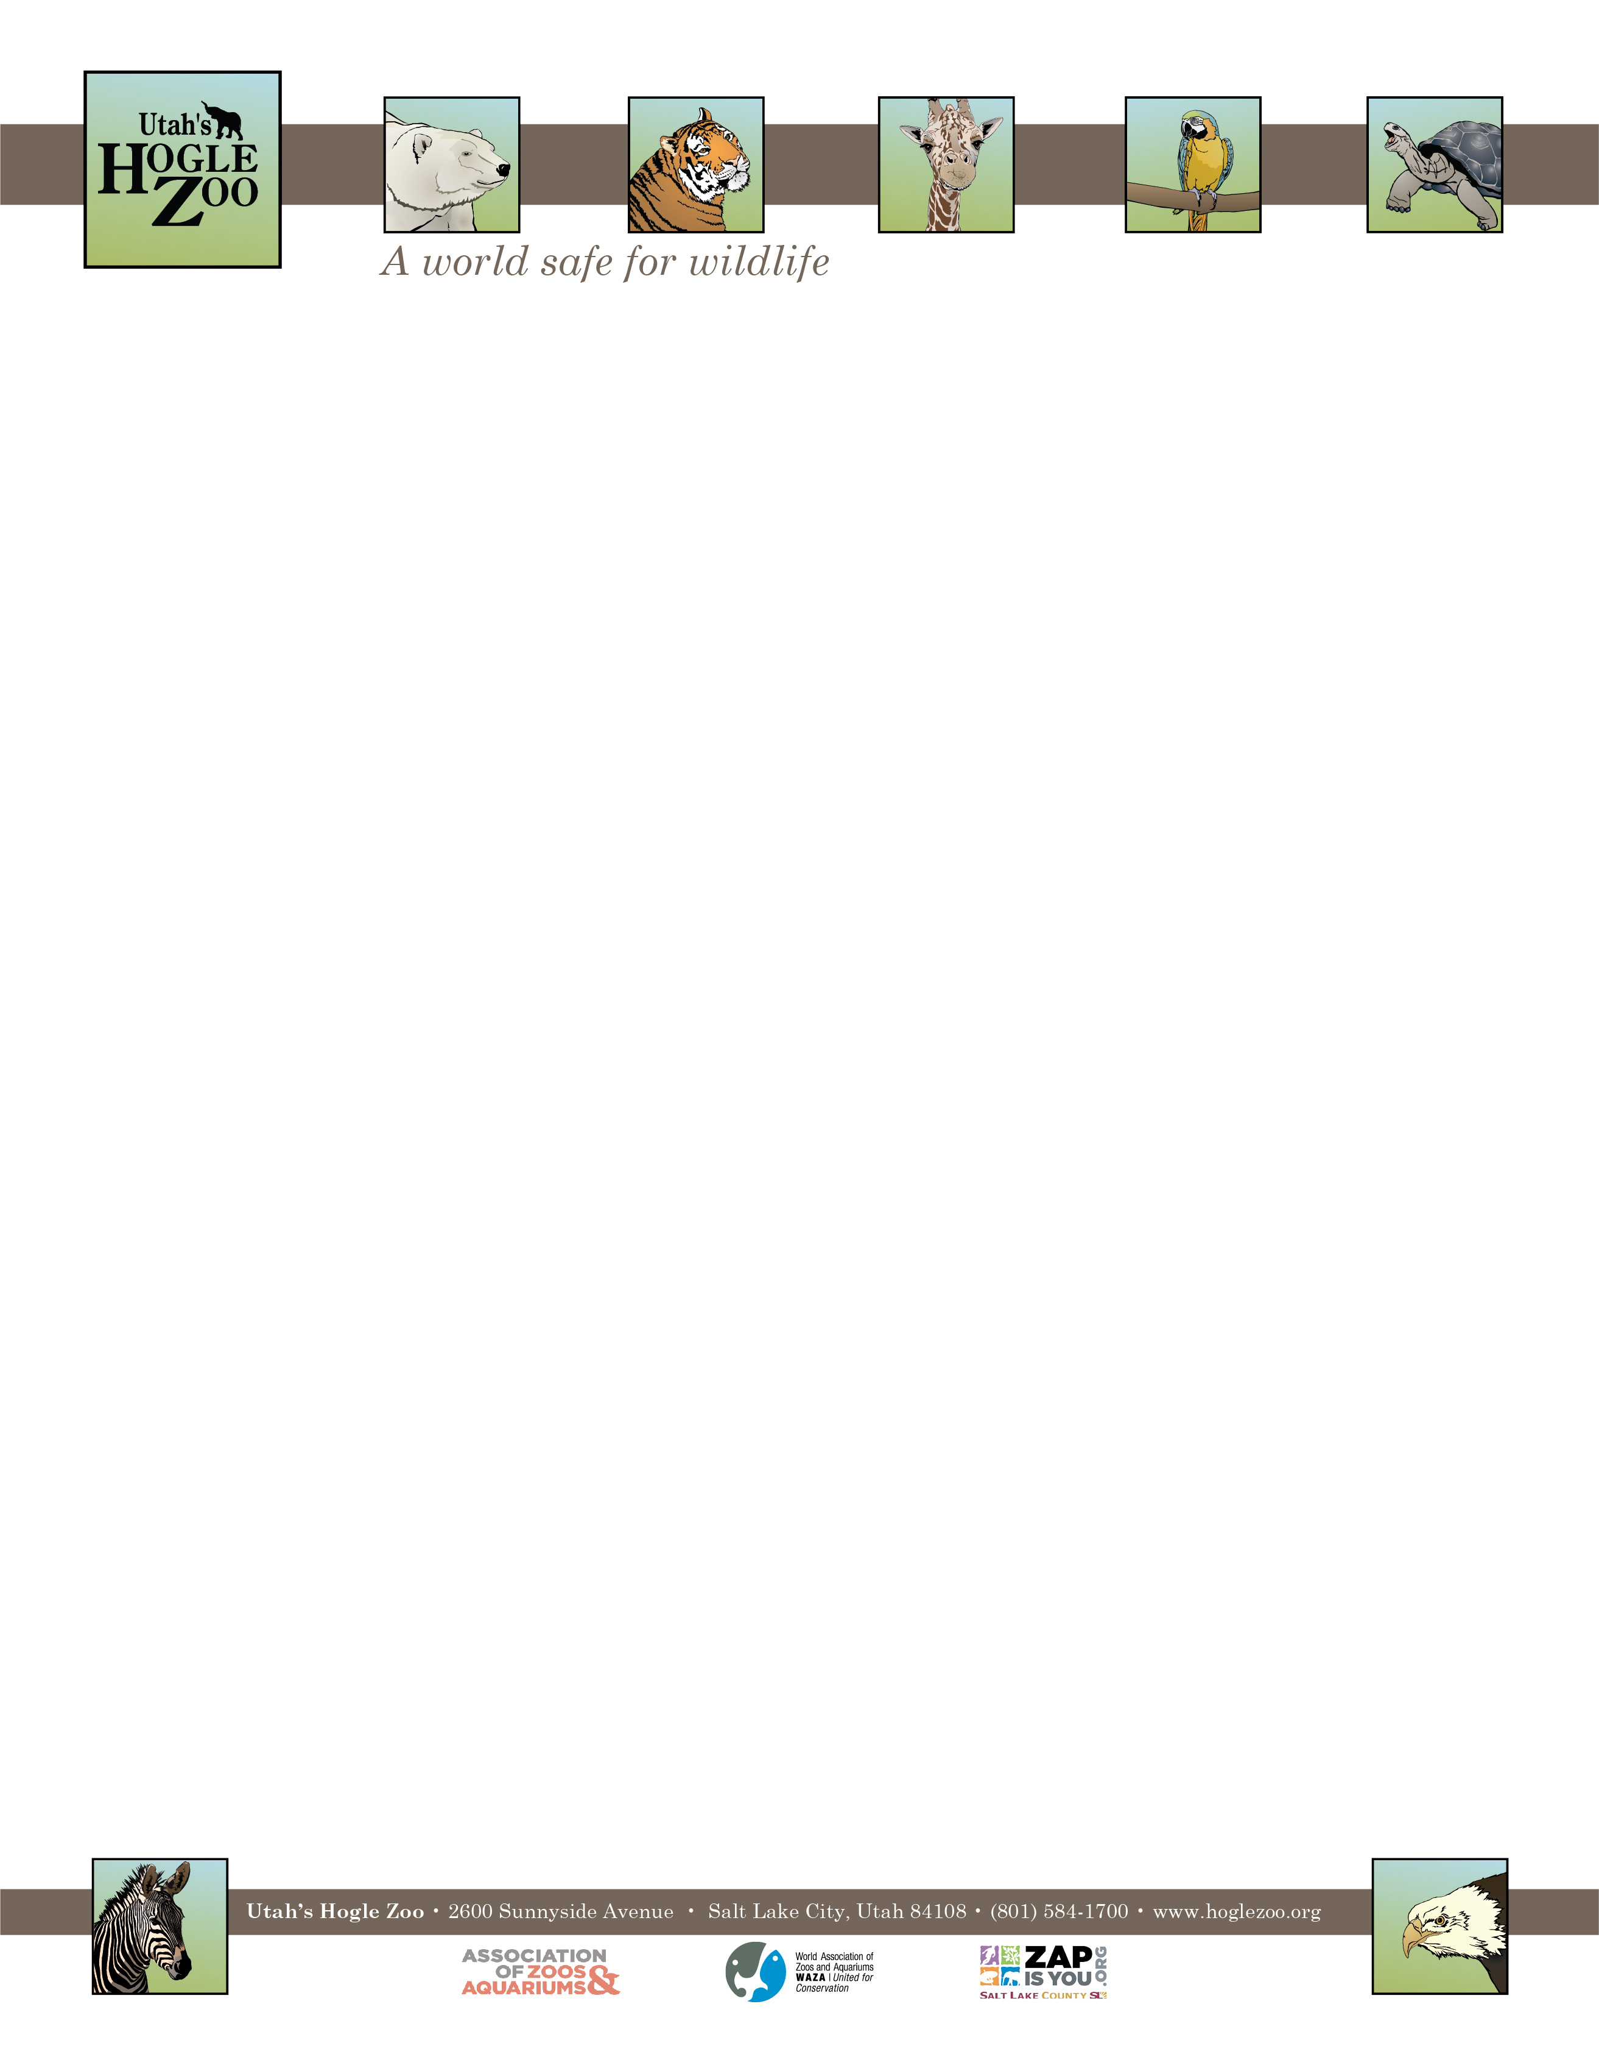

**Organization:** Utah’s Hogle Zoo (AZA Member) **Internship:** Tropics Zone-Small Animal Building Internship (Mammals, Reptiles and Birds)

**Location:** Salt Lake City, Utah, United States

**POSITION SUMMARY:**

This internship is geared towards college students and recent graduates who are interested in playing a direct role in caring for a variety of birds, mammals, insects, reptiles and amphibians. All applicants should be organized, self-motivated and have excellent people skills. This internship is an in-depth program requiring a 40 hour per week commitment for 12 weeks. Interns must be flexible with their schedule, and have the ability to work weekdays, weekends and holidays. It is an unpaid position and there is no housing provided. All internship positions are on a voluntary basis only. Housing, travel expenses and transportation are the responsibilities of the candidate.

**REPORTS TO:** Animal Care Supervisor of Small Animal Building

**DATES:** Summer: May 23- August 15, 2022 (start and end date may be flexible on a case by case basis)

**POSITION DESCRIPTION:**

There is currently a small mammal/bird intern positions for the Small Animal Building in the Tropics Zone. Interns will have the opportunity to assist with the care of straw-colored fruit bats, burrowing owls, amazon parrots, kinkajou, two-toed sloth, titi monkeys, African-crested porcupines, hornbills, kookaburra, and a variety of reptiles and amphibians. All SAB interns will have the opportunity to work with the multiple bird species in the rain forest aviary as well as the giant Aldabra tortoises.

Animal collections may change over time depending on the needs of the building. The selected candidates will assist the Keeper staff in all aspects of maintaining mammal, bird and reptile exhibit collections at the Zoo’s Small Animal Building. This internship is designed to provide instruction in the following areas: animal husbandry, nutrition and diets, record keeping, exhibit maintenance, enrichment and training, as well as public education and knowledge of a variety of animals. Intern duties may include the following under keeper supervision (may vary based on skill level and departmental needs):

1. Assist with exhibit maintenance and cleaning
2. Prepare daily diets and perform daily feeding
3. Assist in the maintenance of back-up areas
4. Conduct precise record-keeping
5. Assist with exhibit construction
6. Provide positive and educational interaction with zoo guests
7. Participate in animal enrichment and select training
8. Complete various projects

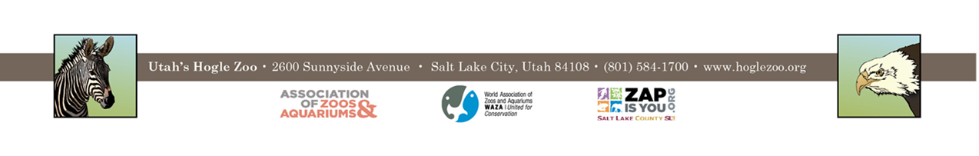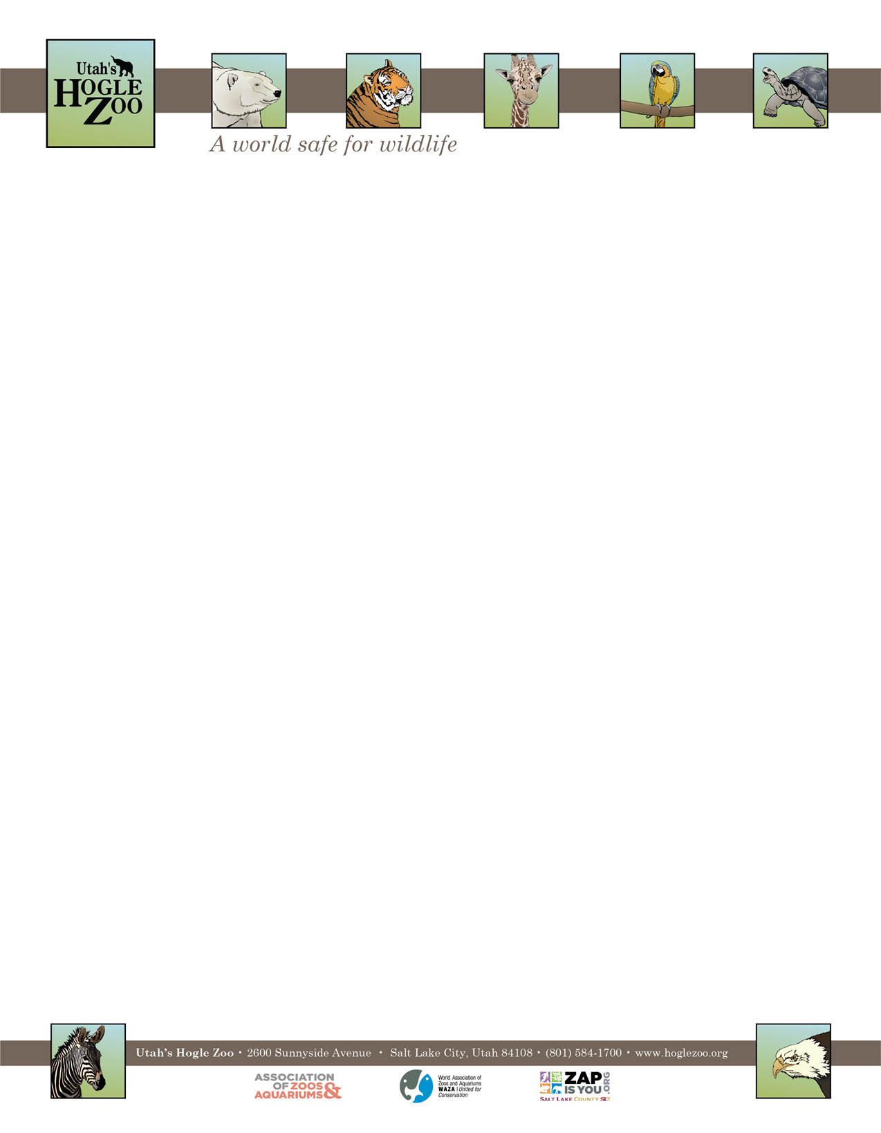

**QUALIFICATIONS:**

Be currently enrolled in/ or have recently graduated from a college or university. Have a minimum of one year of course work in a major field of study to be applied during the internship (e.g. Biology, Zoology, Environmental Science, etc.). Experience working with mammals and birds is preferred. Applicants should have a strong career interest in animal husbandry. Candidates should be able to lift 50 pounds, need to have a recent TB test and tetanus shot. The applicant needs to demonstrate maturity, self-motivation, and an ability to follow direction. A basic knowledge and understanding of computer word processing and PowerPoint is helpful. The ability to gain and hold a driver’s license is required. They must also pass a background check and a drug test if selected.

**WORK SCHEDULE:** 40 hours a week for a minimum of 12 weeks. Interns are expected to work on holidays and weekends.

**COMPENSATION:** The Small Animal Building Intern position is unpaid. Professional development opportunities will be available. Possible college credit is available for those able to receive it through their college/university. No housing provided.

**TO APPLY:** Applications are due by **February 14, 2022**.

Please visit <https://www.hoglezoo.org/jobs_volunteers/internships/> to fill out an application. In addition to completing the application send a resume, cover letter, and informal transcript to [volunteeroffice@hoglezoo.org](mailto:volunteeroffice@hoglezoo.org)  .

Applicants will be contacted for interviews at the end of February, please do not expect to hear from us before then.

Please e-mail volunteeroffice@hoglezoo.org with any questions.

**Utah’s Hogle Zoo is committed to providing a diverse and inclusive internship program representative of a variety of backgrounds, age groups, perspectives, experiences, abilities, and strengths.**