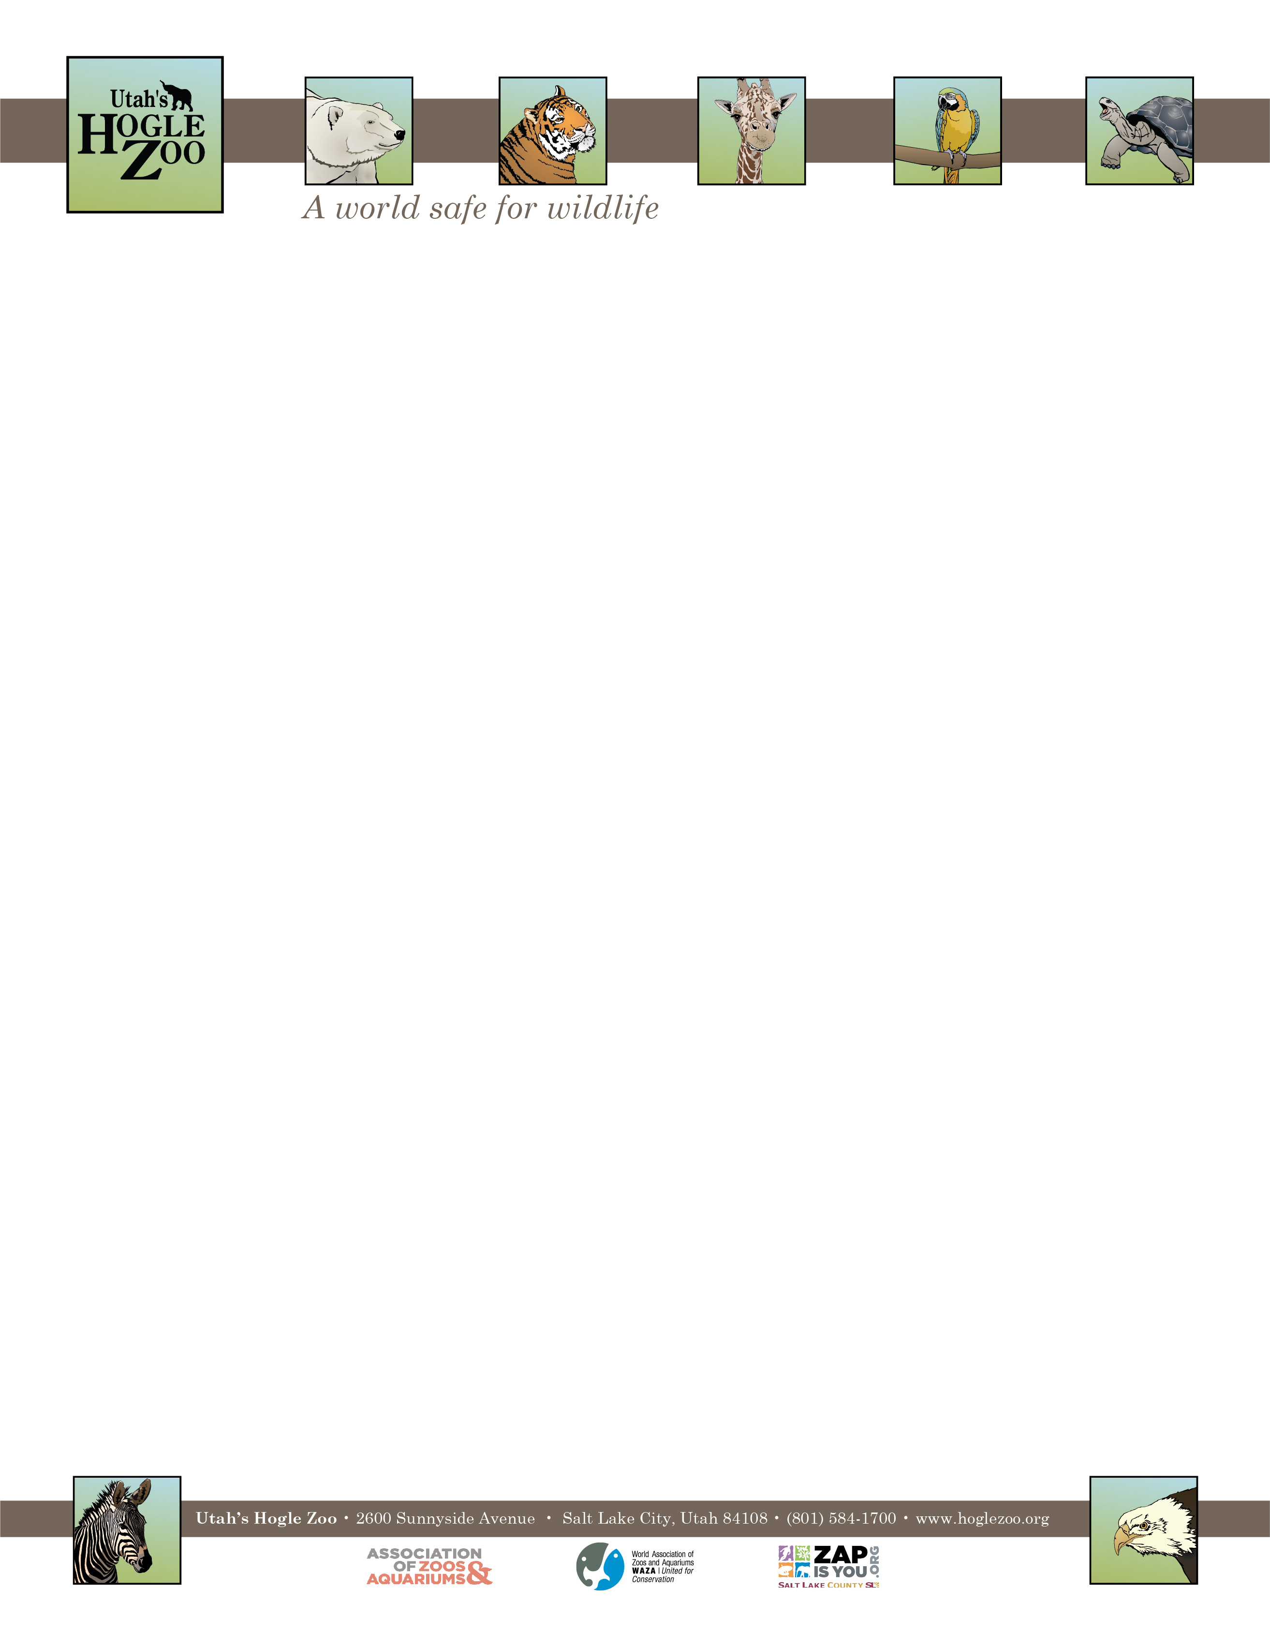

**Organization:** Utah’s Hogle Zoo (AZA Member) **Internship:** Primate Internship

**Location:** Salt Lake City, Utah, United States

**POSITION SUMMARY:**

This internship is geared towards college students and recent graduates who are interested in playing a direct role in caring for primates. All applicants should be organized, self-motivated and have excellent people skills. This internship is an in-depth program requiring a 40 hour per week commitment for 12 weeks. Interns must be flexible with their schedule, and have the ability to work weekdays, weekends and holidays. It is an unpaid position and there is no housing provided. All internship positions are on a voluntary basis only. Housing, travel expenses and transportation are the responsibilities of the intern.

**REPORTS TO:** Animal Care Supervisor of Primates

**DATES:** Summer: May 23- August 15, 2022 (start and end date may be flexible on a case by case basis)

**POSITION DESCRIPTION:**

The selected candidate will assist the Keeper staff in most aspects of caring for the Zoo’s primates. This includes but does not guarantee the following species: Western Lowland gorilla, Bornean orangutan. black headed spider monkey, black handed spider monkey, black howler monkey, colobus monkey. This internship is designed to provide instruction in the following areas: animal husbandry, nutrition and diets, record keeping, public education and knowledge of primates.

**No direct contact with primates will be permitted**

Intern duties may include the following under keeper supervision (may vary based on skill level and departmental needs):

1. Diet preparation and feeding
2. Cleaning of animal exhibits and holding areas
3. Exhibit maintenance
4. Observing and recording animal condition, behaviors, and responses
5. Positive and educational interaction with zoo guests
6. Animal enrichment
7. Opportunities to observe training

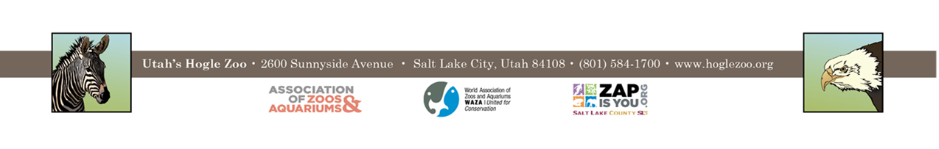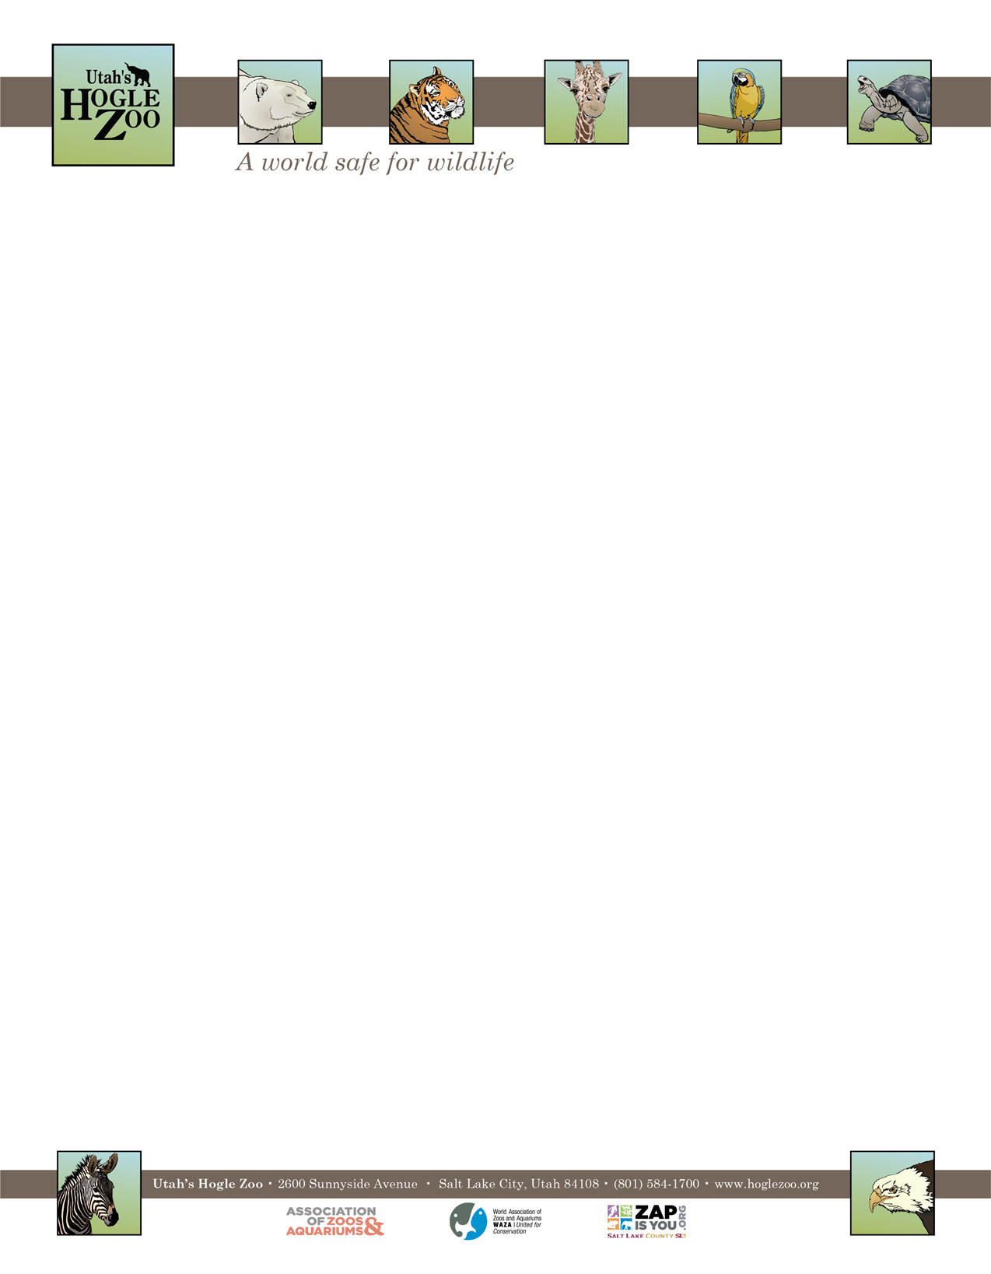

**QUALIFICATIONS:**

Be currently enrolled in a college or university, or have recently graduated. Have a minimum of one year of course work in a major field of study to be applied during the internship (e.g. Biology, Zoology, Environmental Science, etc.). Experience working with mammals preferred. Applicant should have a strong career interest in animal husbandry in a zoological setting. Qualified applicants must be able to work in a team environment, able to lift 50 pounds and work outdoors in the typical Utah climate. Interns need to have a recent TB test, and tetanus shot. They must also pass a background check and a drug test if selected. The applicant needs to demonstrate maturity, self-motivation, and an ability to follow direction. A basic knowledge and understanding of computer word processing and PowerPoint is helpful. The ability to gain and hold a driver’s license is required. First Aid/CPR certified preferred.

**WORK SCHEDULE:** 40 hours a week for a minimum of 12 weeks. Interns are expected to work on holidays and weekends.

**COMPENSATION:** The Primate Internship is unpaid. Professional development opportunities will be available. Possible college credit is available for those able to receive it through their college/university. No housing provided.

**TO APPLY:** Applications are due by **February 14, 2022**.

Please visit <https://www.hoglezoo.org/jobs_volunteers/internships/> to fill out an application. In addition to completing the application send a resume, cover letter, and informal transcript to [volunteeroffice@hoglezoo.org](mailto:volunteeroffice@hoglezoo.org)  .

Applicants will be contacted for interviews at the end of February, please do not expect to hear from us before then.

Please e-mail volunteeroffice@hoglezoo.org with any questions.

**Utah’s Hogle Zoo is committed to providing a diverse and inclusive internship program representative of a variety of backgrounds, age groups, perspectives, experiences, abilities, and strengths.**