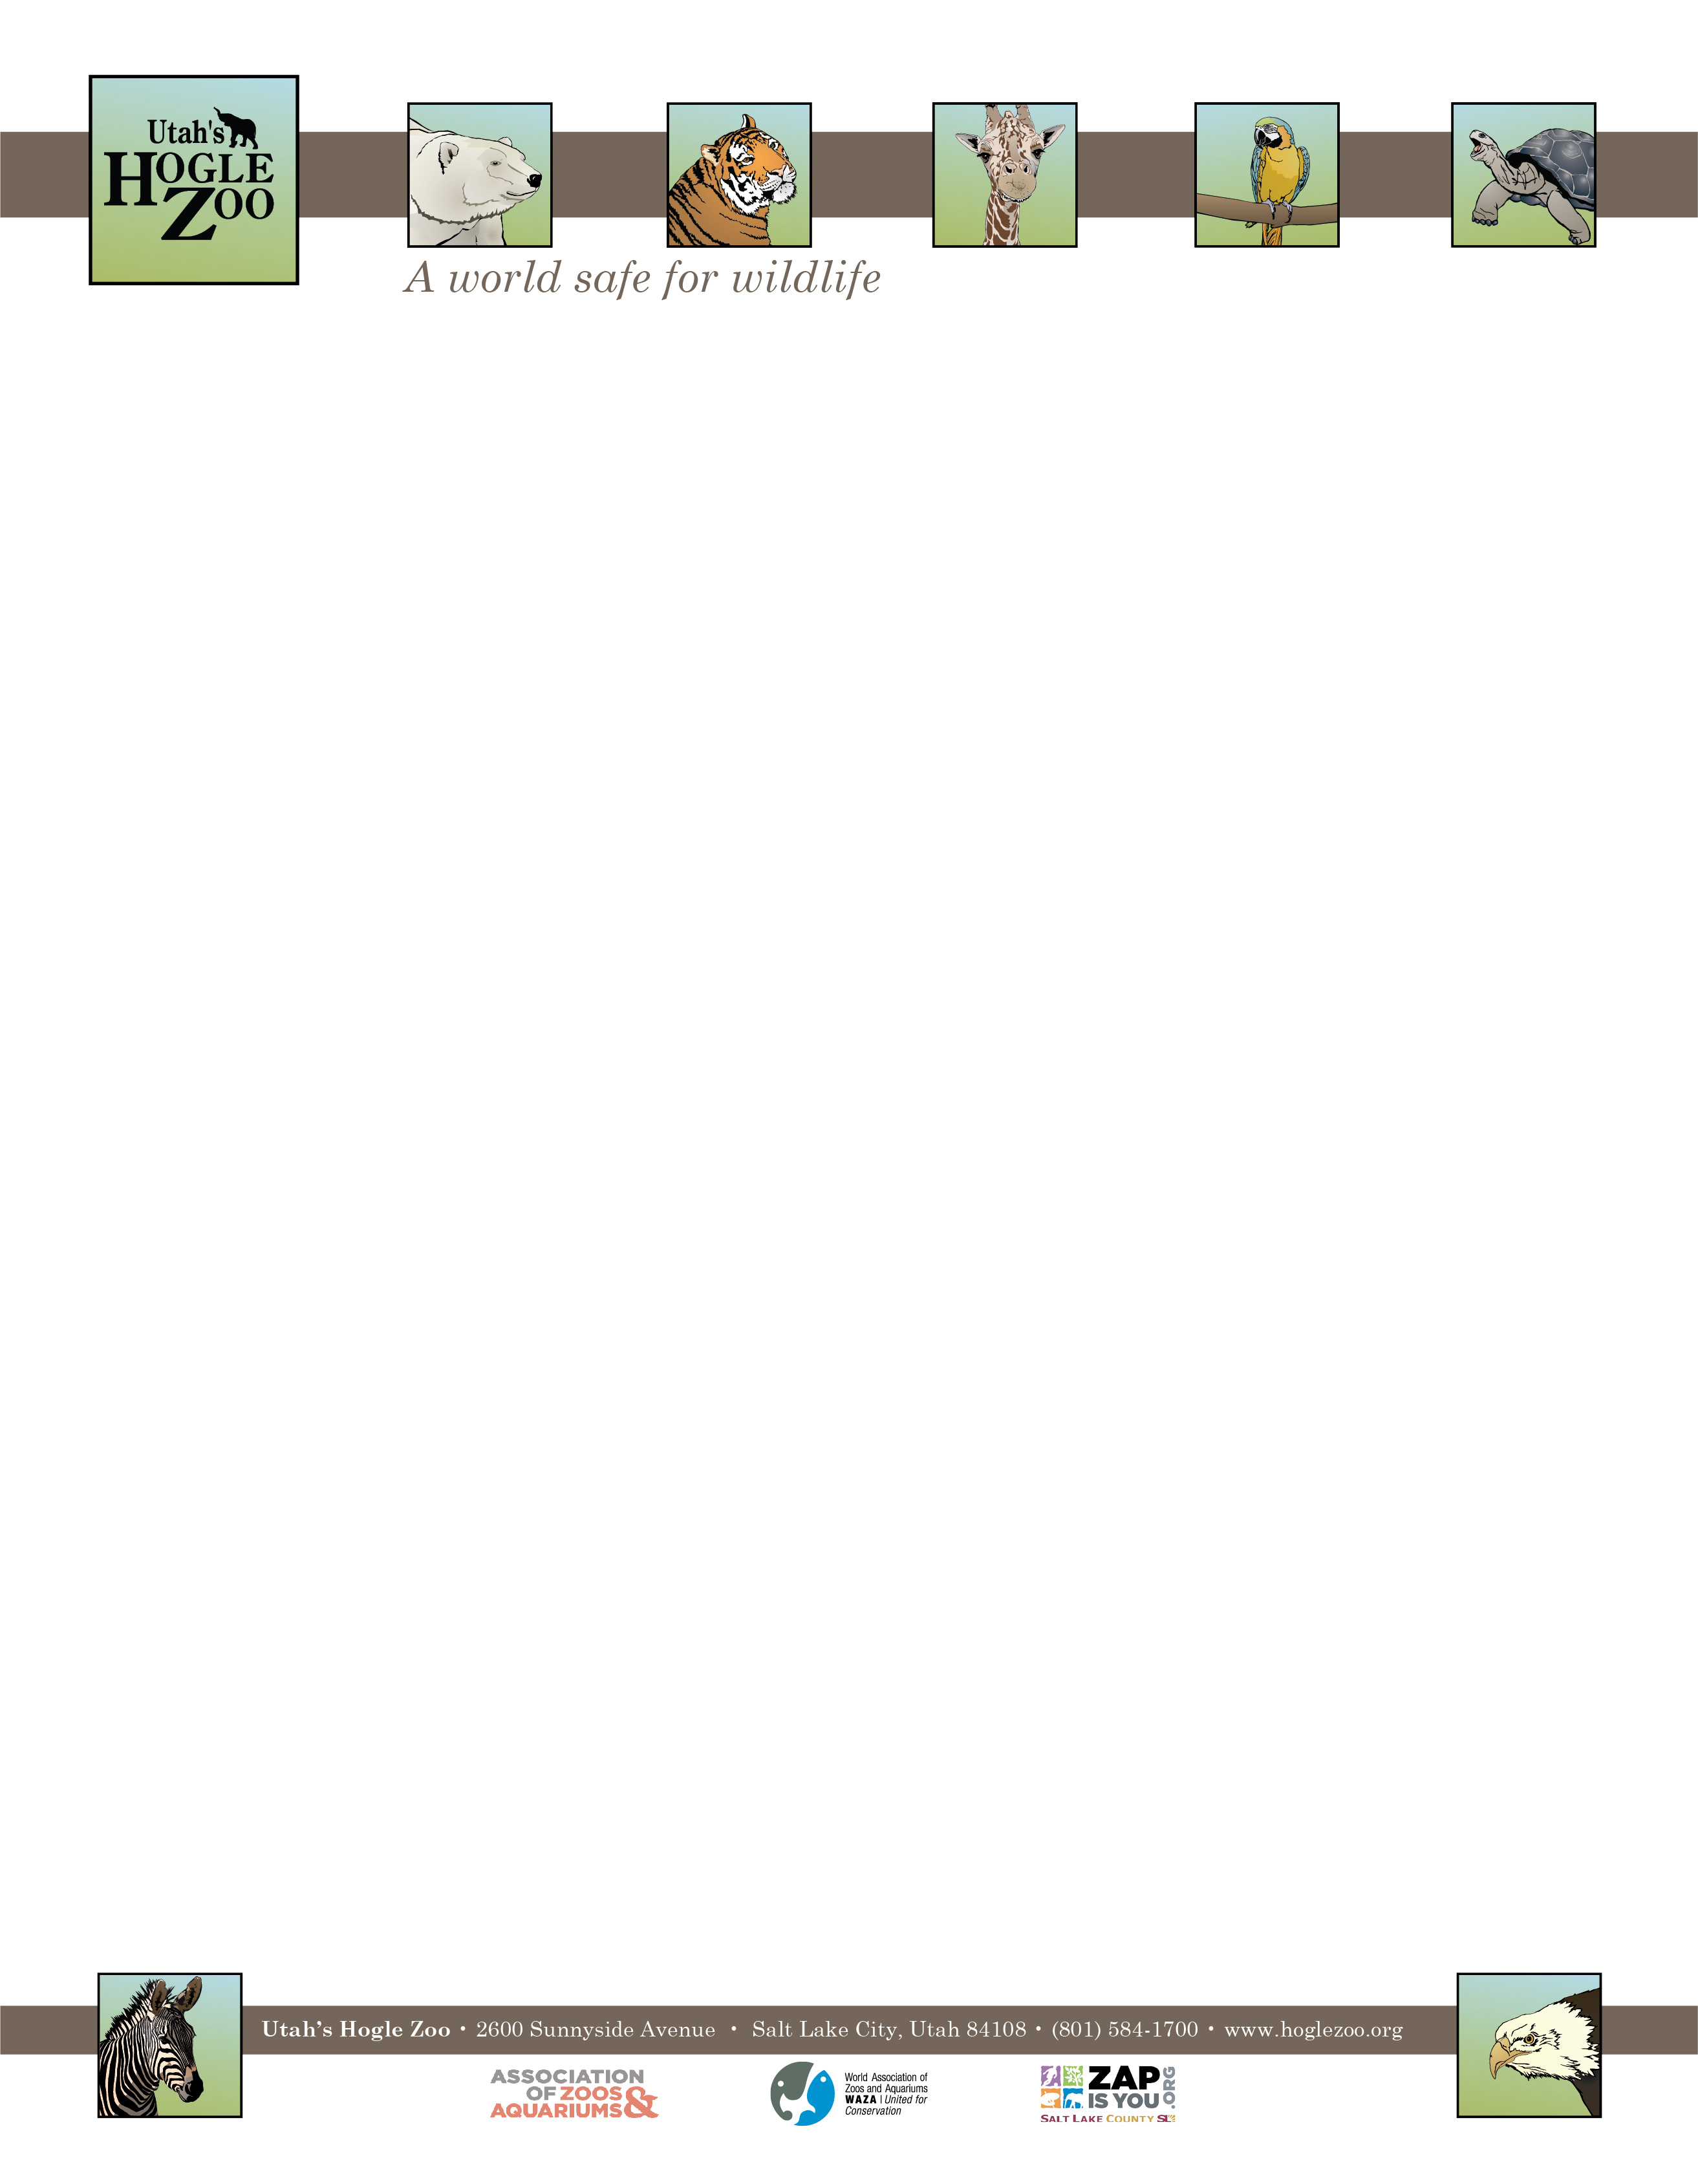

**Organization:** Utah’s Hogle Zoo (AZA Member)

**Internship:** Elephant Encounter Internship

**Location:** Salt Lake City, Utah, United States

**POSITION SUMMARY:**

This internship is geared towards college students and recent graduates who are interested in playing a direct role in caring for African Elephants, White Rhinos, and Bald Eagles.

All candidates should be organized, self- motivated, dependable, positive, have excellent people skills, and show an interest in pursuing a career in animal care management. This internship is an in-depth program requiring a 40-hour per week commitment for 12 weeks. Interns must be flexible with their schedule and have the ability to work weekdays, weekends, and holidays. It is an unpaid position; housing, travel expenses and transportation are the responsibilities of the candidate. Interns will need to complete a final project and keep a weekly journal as part of their internship.

**REPORTS TO:** Animal Care Supervisor ofElephant Encounter

**DATES:** Summer May 23- August 15, 2022 (start and end date may be flexible based on school schedule)

**POSITION DESCRIPTION:**

Interns will assist in the care of our 2 African Elephants, 2 White Rhinos, and 2 Bald Eagles. From barn and exhibit maintenance to enrichment and observation of training sessions this position will give real world experience in the field of zoo animal keeping. **No direct elephant contact will be permitted**

This internship is designed to provide instruction in the following areas:

* Animal husbandry
* Nutrition and diets
* Record keeping
* Public education

Intern duties may include the following under keeper supervision (may vary based on skill level and departmental needs)

* Diet preparation and feeding
* Proper nutrition and care for the animals in the collection
* Maintaining of animal exhibits and holding areas according to USDA and AZA regulations
* Observing and recording animal conditions, behaviors and responses
* Animal enrichment
* Observation of training sessions
* Positive and educational interactions with zoo guests

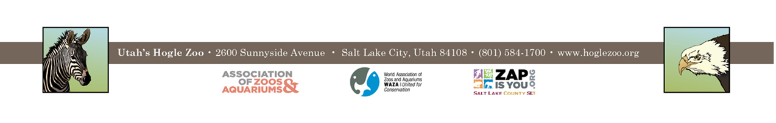

**QUALIFICATIONS:**

Applicant should have a strong career interest in animal husbandry and informal education in a zoological setting. Applicant should currently be enrolled in a college or university and have a minimum of one year of course work in a major field of study to be applied during the internship (biology, zoology, environmental science, or a related field.) or have recently graduated. Previous experience working with animals preferred.

Qualified applicants must be able to work in a team environment with people of all ages. They should be able to lift 50 pounds and work outdoors in the typical Utah climate. Interns need to have a recent TB test and Tetanus shot. The applicant needs to demonstrate maturity, self-motivation, and an ability to follow direction. A basic knowledge and understanding of computer word processing, Excel spreadsheets, and PowerPoint is helpful. The ability to gain and hold a driver’s license is required. First Aid/CPR certified preferred.

**WORK SCHEDULE:** 40 hours a week for a minimum of 12 weeks (holidays and weekends may be required)

**COMPENSATION**: The Elephant Encounter internship is unpaid. Professional development opportunities will be available. Possible college credit is available for those able to receive it through their college/university. No housing provided.

**TO APPLY:** Applications are due by **February 14 2022**.

Please visit <https://www.hoglezoo.org/jobs_volunteers/internships/> to fill out an application. In addition to completing the application send a resume, cover letter, and informal transcript to [volunteeroffice@hoglezoo.org](mailto:volunteeroffice@hoglezoo.org)  .

Applicants will be contacted for interviews at the end of February, please do not expect to hear from us before then.

Please e-mail volunteeroffice@hoglezoo.org with any questions.

**Utah’s Hogle Zoo is committed to providing a diverse and inclusive internship program representative of a variety of backgrounds, age groups, perspectives, experiences, abilities, and strengths.**