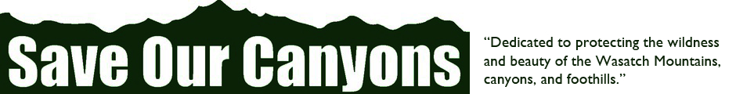
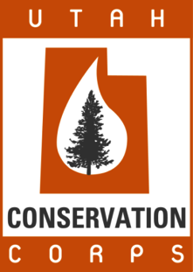
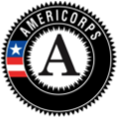

NOW HIRING!

AmeriCorps Education and Stewardship Coordinator
With Save Our Canyons

Save Our Canyons, a local 501c3 non-profit organization, in conjunction with Utah Conservation Corps is seeking a qualified individual to help facilitate and implement youth education programs, community outreach, and environmental stewardship projects in the Wasatch Mountains between June 2018 – December 2018. Position is based in Salt Lake City, Utah.

The Save Our Canyons Kids program and Wilderness Stewardship Program will be the primary projects for this position. Successful candidates will be educating and leading service projects in the Wasatch Mountains, developing educational materials, attending community events to discuss projects, recruiting and coordinating volunteers. The AmeriCorps member will work closely with Save Our Canyons staff, volunteers, and community partners.

Wilderness Stewardship Project – The three Wilderness units that border the Salt Lake Valley
are highly valued, intensely visited areas that provide escape, inspiration and recreation for
millions of visitors every year. As an organization who advocates for wilderness and protection of our public lands, we are partnering with the USFS Salt Lake Ranger District to assist the agency with stewardship and wilderness education.

Save Our Canyons Kids – Provides opportunities for underserved youth populations to visit
and learn about the Wasatch Range’s watershed, flora and fauna, Leave No Trace ethics,
public lands management and protection of natural resource.

This is a paid service position being offered through Utah Conservation Corps’ AmeriCorps Individual Placement program. Candidates must complete a minimum of 675 hours averaging about 22 hours per week. An education award of $2,215 is granted upon completion of hours.

Qualifications

- Education experience
- Experience working with children and youth, preferred
- Ability to present to large groups and interface with a diversity of age groups
- Excellent interpersonal skills
- Personal interest in environmental conservation and sustainability
- Ability to organize and lead service projects

Eligibility Requirements

- Must be a US Citizen or Permanent Resident
- At least age 18 by the start of their term
- Must have a high school diploma or equivalent
- Must undergo and pass a National Criminal History Check
- Eligible to serve in an AmeriCorps State/National term
- Commitment to completing a 675 hour Term of Service

How to Apply

Please submit a cover letter, resume, references, and a writing sample to jobs@saveourcanyons.org by Thursday, May 10, 2018. Please include experience and qualifications relevant to the position description. All requested materials must be supplied in order for consideration. Send questions to the email or phone at 801 363-7283. This is a temporary position currently ending in 2018, but may be extended into 2019.

