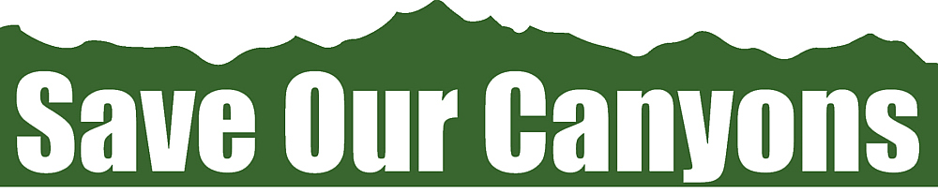

Save Our Canyons Summer Community Development Internship

Save Our Canyons, founded in 1972, is “dedicated to protecting and preserving the beauty and wildness of the Wasatch Mountains, canyons and foothills.” As the only organization specifically dedicated to this range we depend heavily on our membership and the broader community to help further our mission and cause. While we have a dedicated membership, we have a rather small reach in comparison to the population who depend on the Wasatch for water, recreation and economic prosperity.

This internship will provide an opportunity to engage in grassroots community engagement and organizing that will have a direct effect on the health and longevity of the Wasatch Range.

Approx. 10 + hours weekly

Internship Objectives:
- Assist with community and member outreach efforts
- Develop volunteer event schedule to recruit and involve volunteer groups
- Schedule and staff Save Our Canyons information table at community events in strategic cities based on current campaigns and projects

Internship Goals:
- Increase Save Our Canyon’s exposure to a more diverse audience
- Increase email list by 100+ people
- Gain a better understanding of issues facing the Wasatch Range

Save Our Canyons Summer Semester Community Development Internship allows the right candidate an opportunity to work in a creative and collaborate environment to address the various issues facing the Wasatch Range. Applicants should be self-motivated, dynamic and energetic about implementing their skills to help Save Our Canyons further our mission and grow our impact.

To apply for this internship please send resume and cover letter to Alex Schmidt (Alex@saveourcanyons.org). Questions please call 801-363-7283.

