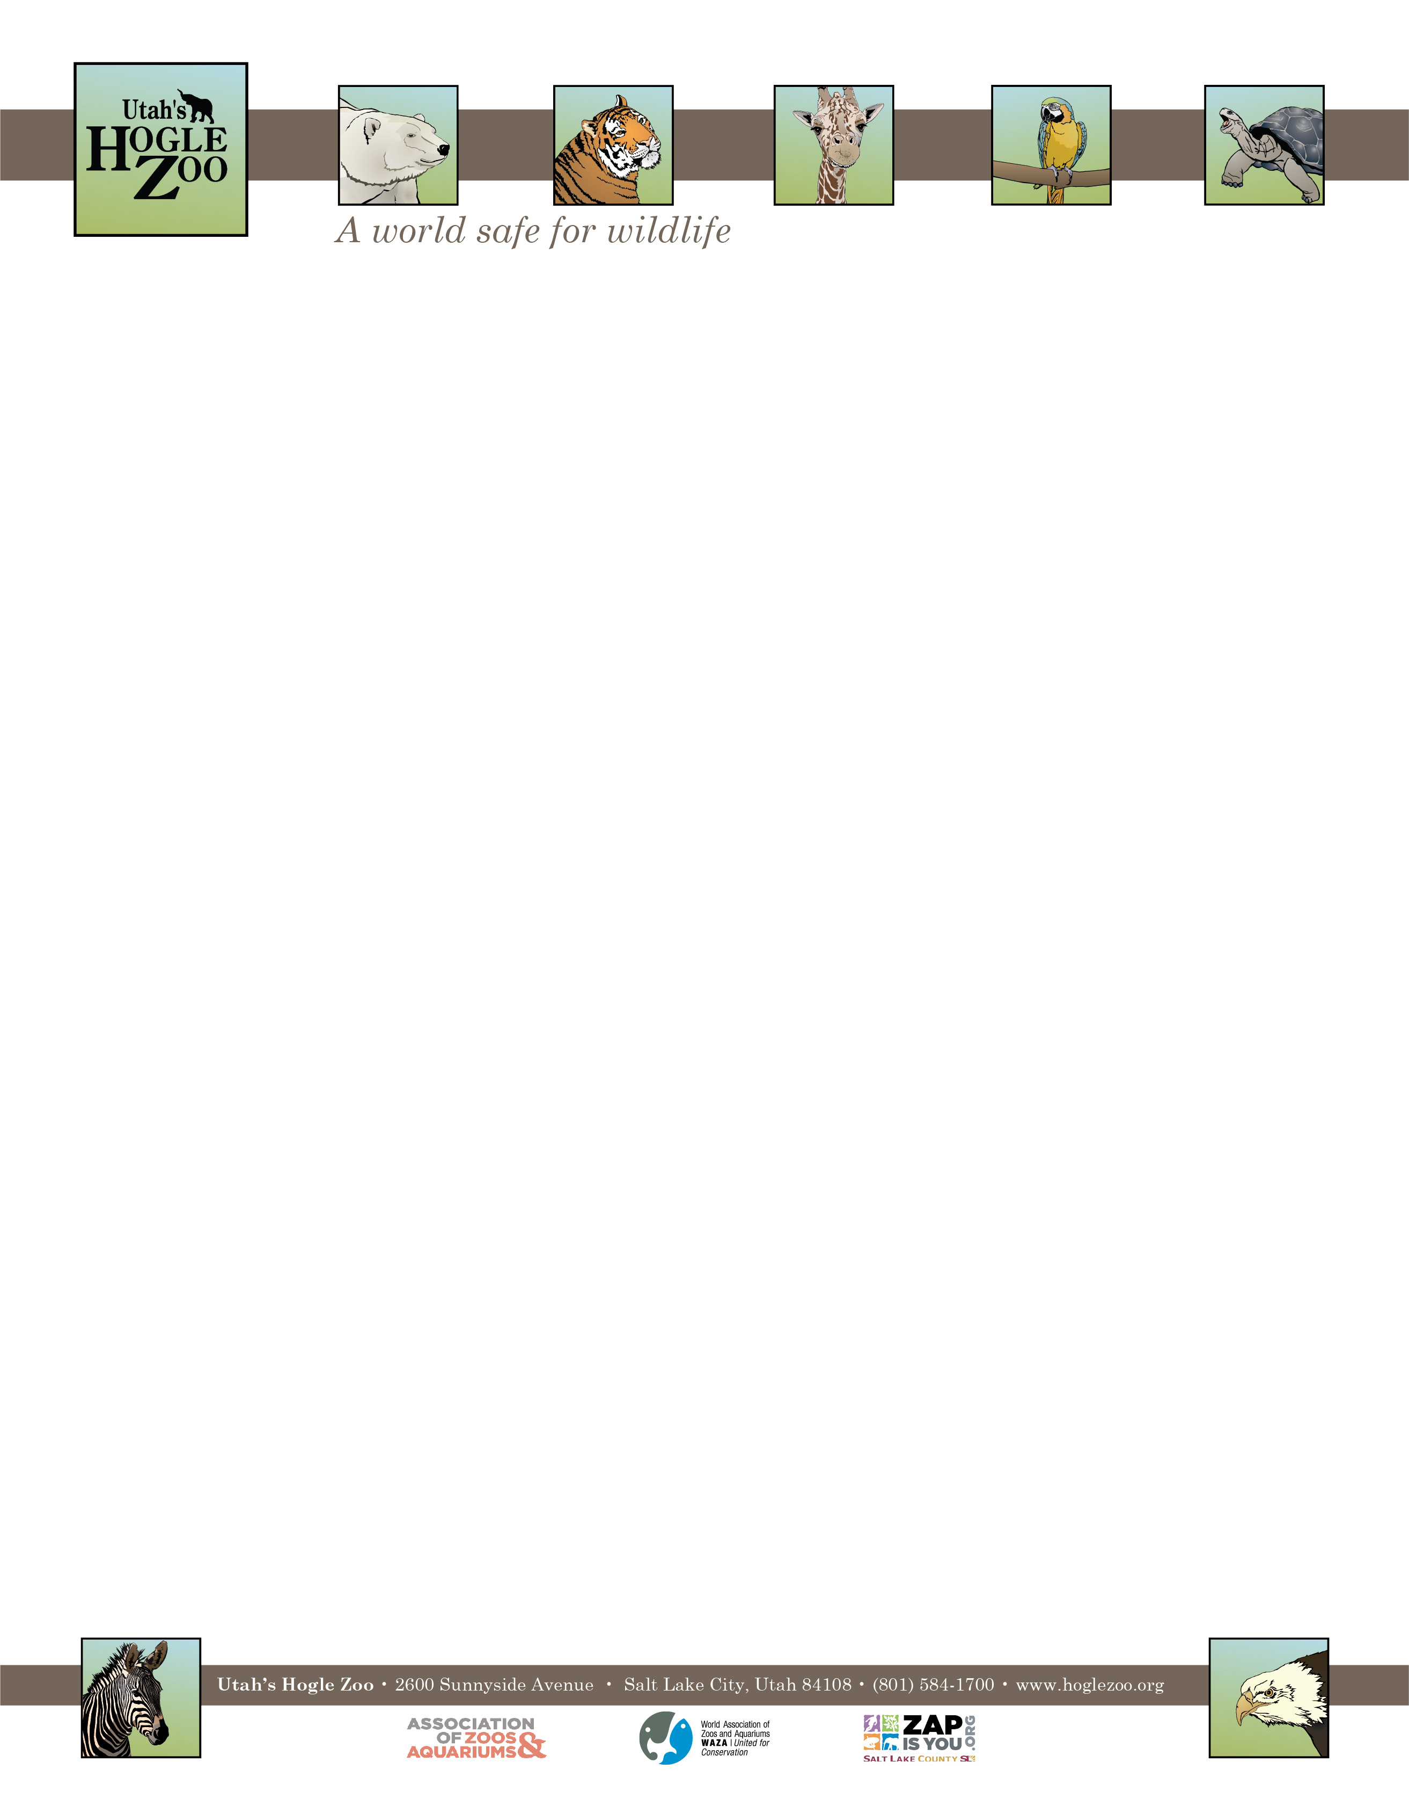

**Organization:** Utah’s Hogle Zoo (AZA Member) **Internship:** Rocky Shores Internship

**Location:** Salt Lake City, Utah, United States

**POSITION SUMMARY:**

This internship is geared towards college students and recent graduates who are interested in playing a direct role in caring for Harbor Seals, California Sea Lions, and North American River Otters, as well as marine fish and invertebrates. Interns will also have the opportunity to indirectly work with Polar Bears and Grizzly Bears. All applicants should be organized, self-motivated and have excellent people skills. This internship is an in-depth program requiring a 40-hour per week commitment for 12 weeks. Interns must be flexible with their schedule and have the ability to work weekdays, weekends, and holidays. This is an unpaid position and there is no housing provided. Housing, travel expenses and transportation are the responsibilities of the intern. Interns will need to complete a project and keep a weekly journal as part of their internship.

**REPORTS TO:** Animal Care Supervisor ofRocky Shores

**DATES:** Summer May 23- August 15, 2022 (start and end date may be flexible based on school schedule)

**POSITION DESCRIPTION:**

The selected candidates will assist the keeper staff in all aspects of caring for the Zoo’s Rocky Shores collection. This internship is designed to provide instruction in the following areas: animal husbandry, training, nutrition and diets, record keeping, public education and knowledge of the species in the area. Intern duties may include the following under keeper supervision (may vary based on skill level and departmental needs):

* Diet preparation and feeding
* Cleaning of animal exhibits and holding areas
* Exhibit maintenance
* Aquarium maintenance
* Observing and recording animal condition, behaviors, and responses
* Positive and educational interaction with zoo guests
* Animal enrichment
* Behavioral ethograms

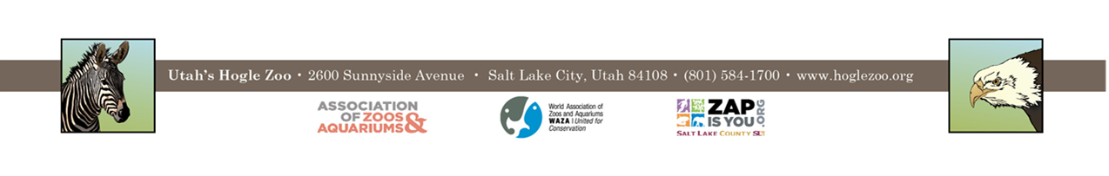

**POSITION DESCRIPTION CONTINUED:**

* Observe and indirectly participate in training with various species
* Narration of training demonstrations using a microphone

**QUALIFICATIONS:** Applicant should have a strong career interest in animal husbandry and informal education in a zoological setting. Applicant should currently be enrolled in a college or university and have a minimum of one year of course work in a major field of study to be applied during the internship (Biology, Zoology, Environmental Science, or a related field) or have recently graduated. Previous animal experience is preferred.

Qualified applicants must be able to work in a team environment with people of all ages. They should be able to lift 50 pounds and work outdoors in the typical Utah summer climate. Applicants interested in a position in Rocky Shores must be able to pass a casual swim test, be comfortable working around water, comfortable with heights and comfortable working in relatively confined spaced. Interns need to have a recent negative TB test and a tetanus shot is recommended. The applicant needs to demonstrate maturity, self-motivation, and an ability to follow direction. A basic knowledge and understanding of computer word processing, Excel spreadsheets, and PowerPoint is helpful. The ability to gain and hold a driver’s license is required. First Aid/CPR certified preferred.

**WORK SCHEDULE:** 40 hours a week for a minimum of 12 weeks. Interns are expected to work on holidays and weekends.

**COMPENSATION:** The Rocky Shores internship is unpaid. Professional development opportunities will be available. Possible college credit is available for those able to receive it through their college/university. No housing is provided.

**TO APPLY:** Applications are due by **February 14, 2022**.

Please visit <https://www.hoglezoo.org/jobs_volunteers/internships/> to fill out an application. In addition to completing the application send a resume, cover letter, and informal transcript to [volunteeroffice@hoglezoo.org](mailto:volunteeroffice@hoglezoo.org)  .

Applicants will be contacted for interviews at the end of February, please do not expect to hear from us before then.

Please e-mail volunteeroffice@hoglezoo.org with any questions.

**Utah’s Hogle Zoo is committed to providing a diverse and inclusive internship program representative of a variety of backgrounds, age groups, perspectives, experiences, abilities, and strengths.**