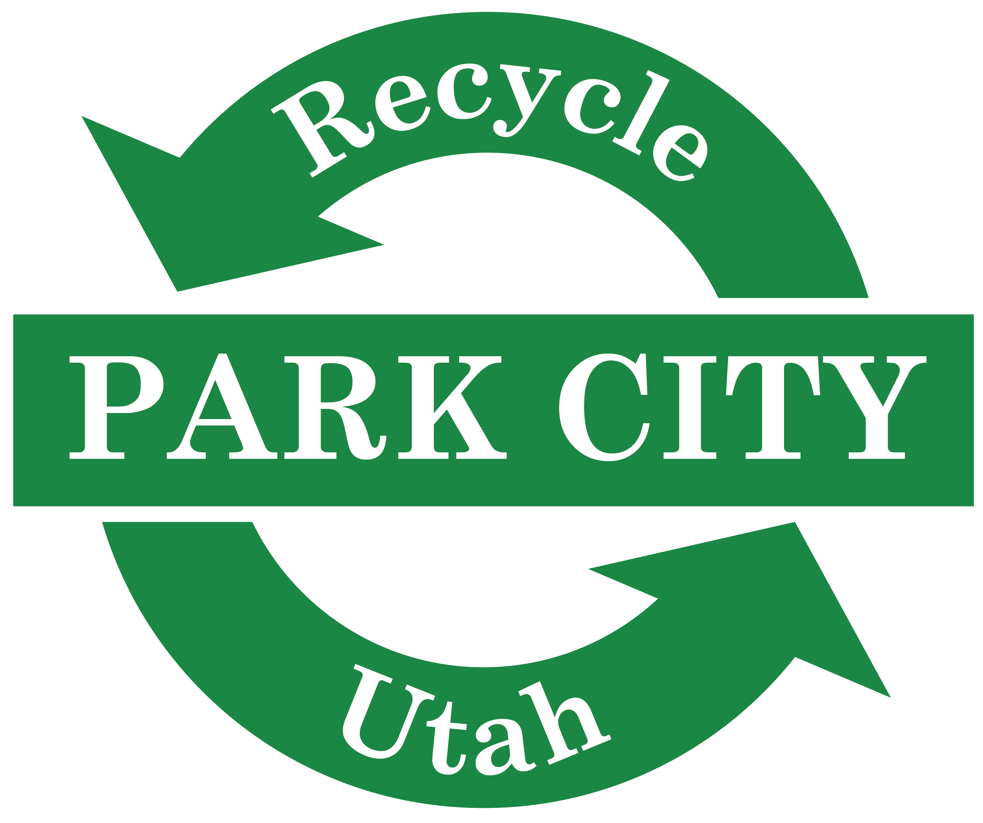

RECYCLE UTAH EDUCATION & OUTREACH INTERNSHIP
Title: Sustainable Business Intern OR Sustainable Education Intern

Recycle Utah, located in the heart of Park City, offers internships throughout the year in the spring (January – May), summer (May – August), and fall (September – December). If you are interested in gaining practical experience in environmental education K-8 and business outreach, this may be an ideal position for you. Additional responsibilities include outreach and marketing, environmental advocacy, and working with customers at our drop-off center. Opportunity exists to create your own project, the beauty of the non-profit industry.

Recycle Utah is seeking an intern to assist our staff with the following in Winter 2022:

Green Business Program Enhancement
- Assist with promotion and maintenance of our Green Business program.
- Approach community businesses to join newly enhanced program
- Assist with updating and expanding materials for the program

Recycle Utah Center Customer Service
- Help us operate Recycle Utah’s bustling center (at least 3 hrs/week)
- Be available for customers (approximately 400/day)
- Perform simple manual work with moving recyclables, equipment, etc…

Education
- Represent Recycle Utah at outreach events across Summit County
- Teach K-5 students as desired with Education Director
- Write Green Tips for the local paper and assist with miscellaneous research projects

Requirements:
- Knowledge of at least interest in Recycle Utah’s work.
- Excellent written and verbal communication skills.
- Friendly and outgoing demeanor.
- Ability to commit 8-10 hours/week, with some evenings/weekends. Hours are flexible.

How to Apply:
- Submit a one-page cover letter, detailing your interest and relevant experience.
- Submit your resume, which should include relevant work and academic experience.
- Submit two professional, or academic references.

Please send application documents to Mary Closser at mary@recycleutah.org.
All interns are eligible for a final stipend after successful completion of the internship and items outlined and signed in Internship Agreement.

