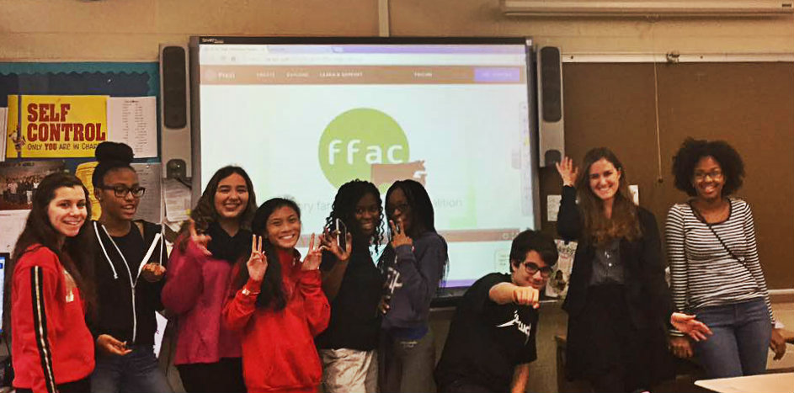

Factory Farming Awareness Coalition
Internship
Spring 2017

Overview
Work with a national non-profit committed to empowering people to help animals, the environment, and our own health through our daily food choices.

Responsibilities
- Analyze the latest media and scientific findings related to the field
- Educate peers through direct outreach
- Liaise with professors and administration regarding campus food policy

Requirements
The ideal candidate will:
- Be willing to commit 40 hours over the course of the semester
- Have strong written and oral communication skills
- Be self-motivated and reliable
- Have good interpersonal skills
- Be passionate about environmental/food/social justice issues

Benefits
Through this resume-building position, you will:
- Gain experience working with a national non-profit organization
- Develop strong public speaking skills
- Learn the different components of running a campaign
- Practice critical thinking and writing skills

To Apply
Email resume and cover letter explaining your interest in the position to internship@ffacoalition.org

