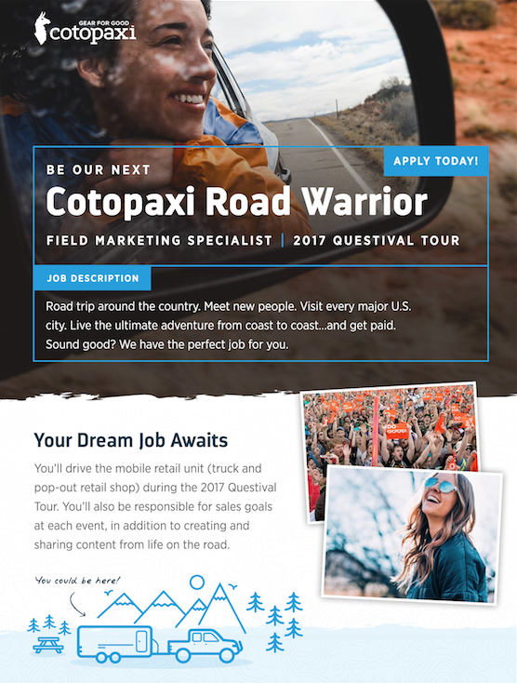
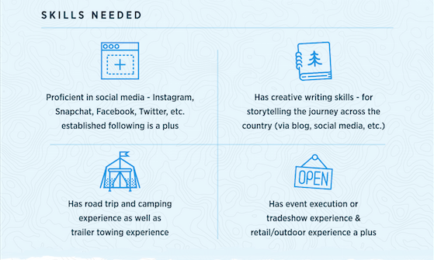
Field Marketing Specialist
Location: On The Road
Full-time
Road trip around the country. Meet new people. Visit every major U.S. city. Live the ultimate adventure from coast to coast...and get paid. Sound good? We have the perfect job for you. Cotopaxi is looking for a Field Marketing Specialist to join the 2017 Questival Tour.

The Field Marketing Specialist reports to the Field Marketing Manager/VP of Marketing. He/she will drive the mobile retail unit (truck and pop-out retail shop) during the 2017 Questival Tour. He/she will also be responsible for sales goals at each event, in addition to creating and sharing content from life on the road.

Responsibilities:
- Drive A LOT and tow a trailer
- Live out of a vehicle (more often than not)
- Set up the mobile retail store
- Educate and guide customers through the Cotopaxi brand and product
- Work closely with the Questival team to execute the on-site retail store
- Manage mobile retail inventory—work with merchandise team to maintain proper levels
- Create content on a regular basis—covering the Tour and adventures in between
- Identify opportunities to increase brand awareness through engagement and activation with potential and current customers

Who You Are:
- A self-starter
- Detail-oriented and organized
- An out-of-the box thinker/problem solver
- Passionate about the outdoors
- An explorer
- A humanitarian at heart

The Ideal Candidate:
- Has retail experience—outdoor industry experience a plus
- Is proficient in social media—Instagram, Snapchat, Facebook, Twitter, etc. (established influencer a plus)
- Has creative writing skills
- Has road trip and camping experience
- Has trailer towing experience
- Has event execution/tradeshow experience
