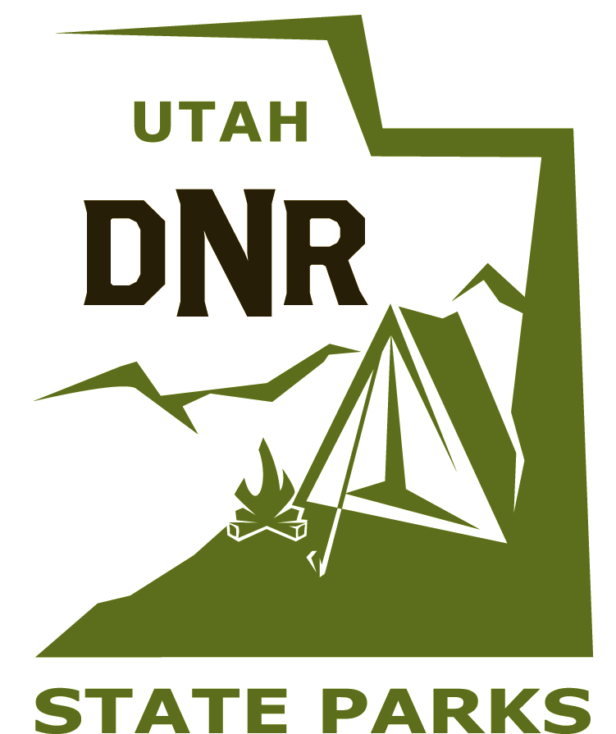Wasatch Mountain State Park

Internship Program

Job Title: Park Ranger Aide/Naturalist Assistant

Supervisor: Kathy Donnell, Park Ranger

Location: Wasatch Mountain State Park, 1281 Warm Springs Rd. Midway, UT., 84049

Time Commitment: Minimum of 10 – 15 hours/week, up to 40 hours/week

Day of the week: Flexible, could include a variety of weekdays/evenings, Saturday’s and Sunday’s

Purpose: This position will assist the Park Ranger/Naturalist in several aspects of the park’s interpretive and trails programs. This internship will provide excellent training for anyone considering a future in environmental education/interpretation

Applications: Send cover letter explaining your background, experience and why you are interested in our internship position, and a resume to: Wasatch Mountain State Park, Attn: Kathy Donnell, PO Box 10 Midway Utah 84049. Or email to [Kathydonnell@utah.gov](mailto:Kathydonnell@utah.gov). For more information about Wasatch Mountain, visit www.stateparks.utah.gov/parks/wasatch.

**Organizational Background**

Wasatch Mountain State Park is tucked away in Utah’s beautiful Heber Valley, its 23,000 acres poised on the east slope of the Wasatch Mountains at an elevation between 6,000 and 10,000 feet. Wasatch is home to an abundance of wildlife such as mule deer, elk, moose, mountain lions, black bear, raccoons, beavers, sandhill cranes, wild turkeys, coyotes and many others.

Wasatch Mountain offers activities year-round such as tent and RV camping, world class golf, scores of hiking, biking, and horseback riding trails, a community fishing pond, cross-country skiing, snowshoeing and ATV riding both summer and winter. Scenic drives and wildlife watching are also popular activities within the park.

Wasatch Mountain also contains a rich history of farming, ranching and homesteading. Several historic buildings still exist within the park, as does an old gravesite with a unique and intriguing history. A 130-year-old apple orchard at the Huber Grove is one of the hidden gems of Wasatch Mountain State Park.

**Relevant Skills:**

Understand principle, theories and practices of parks and recreation, environmental education and interpretation

Develop curriculum, learning objectives and/or course material

Motivated to work alone and with co-workers

Public speaking in front of school and community groups

Customer service/relations

Phone/radio communications and etiquette

Problem solving

Verbal/Non-verbal communications

Ability to read, understand and explain documents in English.

Speak clearly, concisely and effectively

Listen and follow written and/or oral instructions

Availability and approachability

Wide range of physical mobility

Ability to accurately exchange money for fee/service and count back change

Basic office skills including fax machine, copy machine, computer and internet

**Overall Key Intern Responsibilities**

**Depending on your interests you might:**

Create and maintain the online Wildlife Adventure Guide (<https://stateparks.utah.gov/parks/wasatch-mountain/wildlife-adventure/>)

Prepare and present seasonal programs and events

Prepare and present/lead historical tours at the Huber Grove

Lead Interpretive hikes

Help with school programs at the park

Perform trail work as needed

Write interpretive articles for local newspapers

Perform TV and Radio interviews

Prepare interpretive signage (trails, amphitheater, VC)

Promote programs and park through social media

Maintain the Historic Huber Grove including apple tree care, water line repairs, watering trees, weeding and upkeep of house and creamery. Supervise apple harvest.

Maintain geocaching program by filling containers, checking GPS units and coordinates

Assist with preparing for “First Time Camping Adventure” program

Other park-specific duties as needed

**Internship Details:**

This position is currently unpaid, although a small stipend may become available depending on future funding decisions. Wasatch Mountain State Park is approximately 50 miles from Salt Lake City. Housing is not available; however a tent site may be arranged for those interested in camping in the summer to save on travel costs.

